**Fake Credit Card Detection System Using Python**

**Abstract:**  
Credit card fraud is a significant concern in today's digital era. This project focuses on detecting fake credit card transactions using Python-based techniques. The system aims to classify transactions as genuine or fraudulent based on predefined rules and algorithms, improving accuracy and efficiency in fraud detection.

**Introduction:**  
With the rise of online transactions, credit card fraud has become a major challenge for financial institutions. Traditional fraud detection methods, such as rule-based systems, are becoming obsolete due to evolving fraudulent techniques. These systems require continuous updates and manual intervention, making them inefficient for real-time detection.

A Python-based fraud detection system provides a more flexible and efficient solution by automating the detection process. Using various data-processing techniques, algorithms, and predefined validation rules, fraudulent transactions can be identified in real-time with greater accuracy. The system can analyze transaction patterns, detect anomalies, and flag suspicious transactions, reducing financial losses and improving security. Additionally, Python's vast ecosystem of libraries allows for easy implementation of advanced data analysis methods, making fraud detection more effective and adaptable to new fraud trends.

**Existing System:**

* **Advantages:**
  + Basic rule-based fraud detection provides an initial level of security.
  + Simple and easy to implement.
* **Disadvantages:**
  + High false-positive rates.
  + Inefficient against new fraud patterns.
  + Requires manual intervention for updating rules.

**Proposed System:**

* **Advantages:**
  + Uses Python to detect fraudulent transactions more accurately.
  + Reduces manual intervention.
  + Adaptable to new fraud trends using data-driven insights.
* **Limitations:**
  + Requires high-quality transaction data for accurate fraud detection.
  + Computationally expensive for real-time detection.

**System Architecture:**  
The system follows a structured approach:

* **Data Collection:** Historical credit card transaction data is gathered from reliable sources.
* **Data Preprocessing:** The collected data is cleaned, normalized, and relevant features are extracted for analysis.
* **Rule-Based Fraud Detection:** Python scripts analyze transaction patterns using predefined fraud detection rules.
* **Fraud Detection & Validation:** Transactions are classified as genuine or fraudulent based on anomaly detection.
* **System Deployment:** The system is deployed using APIs for real-time fraud detection and prevention.

**Flowchart Representation:**

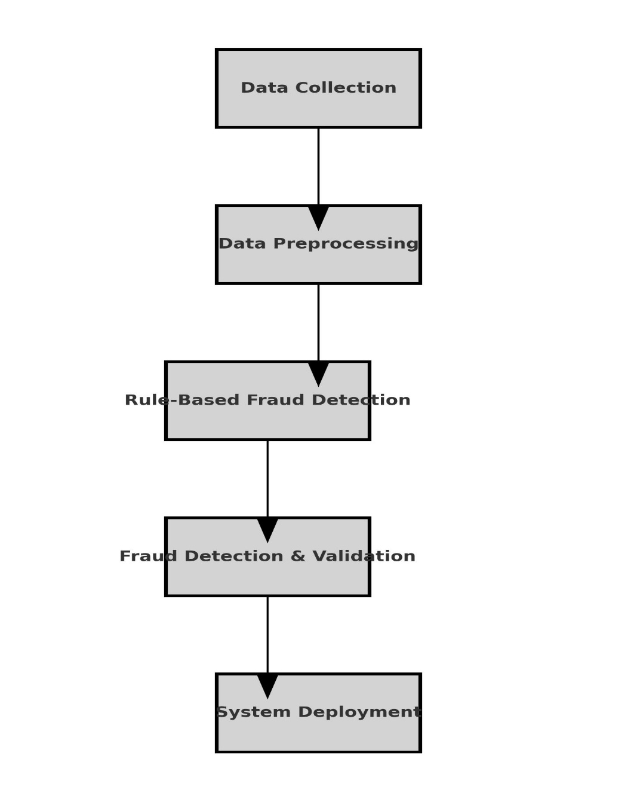

**Scope of the Project:**

The scope of this project is to develop a Python-based fraud detection system that enhances financial security by identifying fraudulent credit card transactions. The system will be capable of:

* Detecting fraudulent transactions in real-time, minimizing financial losses for users and financial institutions.
* Reducing manual intervention through automation, leading to efficient fraud detection processes.
* Enhancing data security by integrating encryption techniques to safeguard transaction details.
* Improving fraud detection accuracy by refining predefined fraud rules and incorporating advanced data analysis.
* Future developments may include the integration of AI-based anomaly detection models and expanding the system to cover multiple types of financial fraud.

This project serves as a foundational step toward creating a robust fraud detection framework, with the potential to scale into a comprehensive fraud prevention system.

**Conclusion:**  
Fake credit card detection is crucial for financial security. This project leverages Python to minimize fraud risks, ensuring safer transactions. Continuous improvements in programming techniques and data analysis will further enhance fraud detection systems. By automating fraud detection and integrating it into banking security infrastructures, the project provides an efficient and scalable approach to fraud prevention.

**Thank You…!**